<!DOCTYPE html>

<html>

                <head>

                <title>Basic mobile app</title>

                <meta charset="utf-8">

                <meta name="viewport" content="width=device-width, initial-scale=1">

                <meta http-equiv="X-UA-Compatible" content="IE=edge,chrome=1">

                <link rel="stylesheet" href="http://code.jquery.com/mobile/1.0rc2/jquery.mobile-1.0rc2.min.css">

                <script type="text/javascript" src="http://code.jquery.com/jquery-1.6.4.min.js"></script>

                <script type="text/javascript" src="http://code.jquery.com/mobile/1.0rc2/jquery.mobile-1.0rc2.min.js"></script>

</head>

<body>

</body>

</html>

Constructing the body content

“data-role="button" is to setup the link as a button. “data-theme="c" switches between 1-5 button. This come packaged by default as CSS styles within jQ Mobile.

<body>

<div data-role="page" id="index">

                <header data-role="header">

                                <h1>Top title bar</h1>

                </header>

               <div data-role="content">

                                <h3>Show another page??</h3>

                                <p>hint: click the button below!</p>

                                <p><a href="#about" data-role="button" data-theme="c">About us</a></p>

                </div>

                <footer data-role="footer">

                                <h2>&copy; footer here.</h2>

                </footer>

</div>

<div data-role="page" id="about">

                <header data-role="header">

                                <h1>Page 2 Here</h1>

                </header>

                <div data-role="content">

                                <p>just some extra content as well.</p>

                                <p>I mean, you can <a data-rel="back" href="#index">go back</a> at any time.</p>

                </div>

</div>

</body>

</html>

Header And Footer Bars

Top Bar Buttons

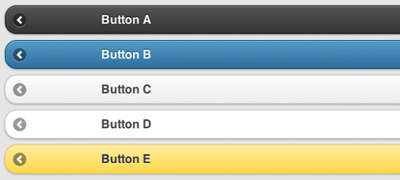

<div data-role="page" id="about" data-add-back-btn="true">

                <header data-role="header">

                                <a href="index.html" data-icon="gear" data-theme="b" class="ui-btn-right">Settings</a>

                                <h1>Page 2 Here</h1>

                </header>

Footer navigation

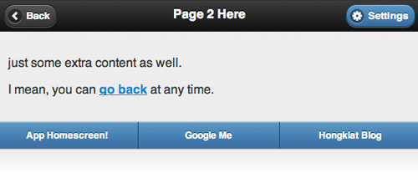

footer data-role="footer" class="ui-body-b">

                <div data-role="navbar">

                                <ul>

                                         <li><a href="#index" data-direction="reverse">App Homescreen!</a></li>

                                                <li><a href="http://www.google.com/" data-rel="external">Google Me</a></li>

                                                <li><a href="http://www.hongkiat.com/" data-rel="external">Hongkiat Blog</a></li>

                                </ul>

                </div>

</footer>

Ajax & Dynamic Pages

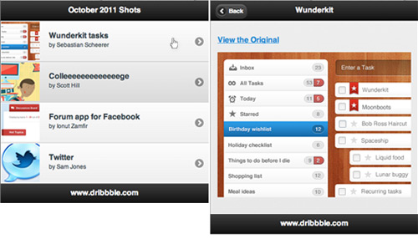

<body>

<div data-role="page" id="img-listing">

                <header data-role="header">

                                <h1>October 2011 Shots</h1>

                </header>

                <div data-role="content">

                                <ul data-role="listview" data-theme="c">

                                                <li><a href="image.php?imgid=1">First image</a></li>

                                                <li><a href="image.php?imgid=2">Second image</a></li>

                                                <li><a href="image.php?imgid=3">Third image</a></li>

                                                <li><a href="image.php?imgid=4">Fourth image</a></li>

                                </ul>

                </div>

                <footer data-role="footer"><h3>www.dribbble.com</h3></footer>

</div>

</body>

</html>

Image Loader Script

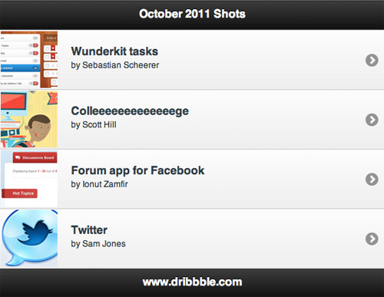

<?php

$theid = $_REQUEST['imgid'];

switch($theid) {

                case 1:

                                $heading = "Wunderkit";

                                $origin  = "http://dribbble.com/shots/297593-Wunderkit-tasks";

                                $source  = "wunderkit.png";

                                break;

                case 2:

                                $heading = "College";

                                $origin  = "http://dribbble.com/shots/298643-Colleeeeeeeeeeeeege";

                                $source  = "college.jpg";

                                break;

                case 3:

                                $heading = "Forum app";

                                $origin  = "http://dribbble.com/shots/298649-Forum-app-for-Facebook";

                                $source  = "forum-app.jpg";

                                break;

                case 4:

                                $heading = "Twitter";

                                $origin  = "http://dribbble.com/shots/298069-Twitter";

                                $source  = "twitter.png";

                                break;

                default:

                                $heading = "Abandoned lighthouse";

                                $origin  = "http://dribbble.com/shots/298615-Abandoned-lighthouse";

                                $source  = "lighthouse.jpg";

}

?>

Image

div data-role="page" id="images" data-add-back-btn="true">

                <header data-role="header">

                                <h1><?php echo $heading; ?></h1>

                </header>

                <div data-role="content">

                                <p><strong><a href="<?php echo $origin; ?>" data-rel="external">View the Original</a></strong></p>

                                <p><a href="<?php echo $origin; ?>" data-rel="external"><img src="img/<?php echo $source; ?>" /></a>                  </p>

                </div>

                <footer data-role="footer"><h3>www.dribbble.com</h3></footer>

</div>

Fancy Design With List Thumbnails

                 div data-role="content">

                <ul data-role="listview" data-theme="c">

                                <li><a href="image.php?imgid=1">

                                <img src="img/wunderkit-t.png" class="ui-li-thumb" />

                                <h3 class="ui-li-heading">Wunderkit tasks</h3>

                                <p class="ui-li-desc">by Sebastian Scheerer</p></a></li>

                                <li><a href="image.php?imgid=2">

                                <img src="img/college-t.jpg" class="ui-li-thumb" />

                                <h3 class="ui-li-heading">Colleeeeeeeeeeeeege</h3>

                                <p class="ui-li-desc">by Scott Hill</p></a></li>

                                <li><a href="image.php?imgid=3">

                                <img src="img/forum-app-t.jpg" class="ui-li-thumb" />

                                <h3 class="ui-li-heading">Forum app for Facebook</h3>

                                <p class="ui-li-desc">by Ionut Zamfir</p></a></li>

                                <li><a href="image.php?imgid=4">

                                <img src="img/twitter-t.png" class="ui-li-thumb" />

                                <h3 class="ui-li-heading">Twitter</h3>

                                <p class="ui-li-desc">by Sam Jones</p></a></li>

                </ul>

               </div>

This is the code for making a facebook sidebar through JQ mobile.

          $(function(){

         var menuStatus;

          $("a.showMenu").click(function(){

          if(menuStatus != true){

         $(".ui-page-active").animate({

            marginLeft: "165px",

          }, 300, function(){menuStatus = true});

          return false;

          } else {

            $(".ui-page-active").animate({

            marginLeft: "0px",

          }, 300, function(){menuStatus = false});

            return false;

          }

          });

        $('.pages').live("swipeleft", function(){

         if (menuStatus){

        $(".ui-page-active").animate({

            marginLeft: "0px",

          }, 300, function(){menuStatus = false});

          }

         });

        $('.pages').live("swiperight", function(){

        if (!menuStatus){

        $(".ui-page-active").animate({

         marginLeft: "165px",

        }, 300, function(){menuStatus = true});

        }

       });

        $("#menu li a").click(function(){

        var p = $(this).parent();

        if($(p).hasClass('active')){

         $("#menu li").removeClass('active');

        } else {

         $("#menu li").removeClass('active');

         $(p).addClass('active');

        }

        });

        });